**CPP NOTES – DAY 06**

**Git file upload**

* Git init
* Git add .
* Git commit -m ‘first commit’
* Git branch -M main
* Git remote add url “url”
* Git push -u origin main

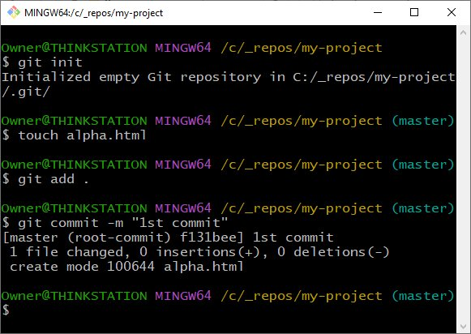

While uploading cpp files two files which are .exe and obj should be ignored via .gitignore.

**Loops**

Used to execute a block of code repeatedly until a certain condition is met. Loops need four points to be considered:

* Initialize variable/counter
* Condition
* Statements to be exec rep
* Counter => inc/dec

int i=0; -🡪 Initialization

while(i<5){

}

At the times of nested loops, reinitialization of variable is required.

**Types**

1. for loop – *for(//initialization ; //condition; //inc/dec)*
2. while loop – *while(condition){ //program }*
3. do while loop – *do(condition){//program}(while-cond)*
4. range based for loop
5. use of lambdas in groups
6. structured bindings in loops